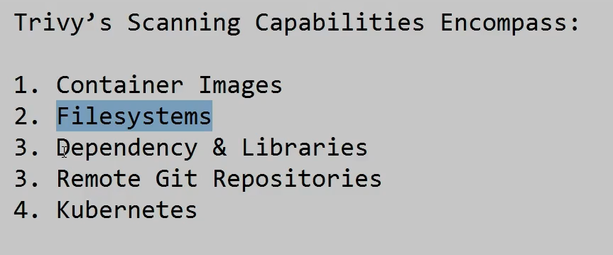

**Different type of format trivy can story**

